flavi@Flavio MINGW64 ~/Desktop/git
$ git config --global user.name "flavio1816" <- Nome de usuário

flavi@Flavio MINGW64 ~/Desktop/git
$

flavi@Flavio MINGW64 ~/Desktop/git
$ git config --global user.email flavio.assisban@gmail.com <- email do cadastro

flavi@Flavio MINGW64 ~/Desktop/git
$ git config –list <-comando para conferir (nome e email)
diff.astextplain.textconv=astextplain
filter.lfs.clean=git-lfs clean -- %f
filter.lfs.smudge=git-lfs smudge -- %f
filter.lfs.process=git-lfs filter-process
filter.lfs.required=true
http.sslbackend=schannel
core.autocrlf=true
core.fscache=true
core.symlinks=false
pull.rebase=false
credential.helper=manager
credential.https://dev.azure.com.usehttppath=true
init.defaultbranch=master
user.name=flavio1816 <- Confere

user.email=flavio.assisban@gmail.com

flavi@Flavio MINGW64 ~/Desktop/git
$

flavi@Flavio MINGW64 ~/Desktop/git
$ git init<- esse comando fala para o git apartir de agora acompanhar toda movimentação da pasta
Initialized empty Git repository in C:/Users/flavi/Desktop/git/.git/

flavi@Flavio MINGW64 ~/Desktop/git (master)<- A partir de agora esta pasta é a máster do projeto
$

flavi@Flavio MINGW64 ~/Desktop/git (master)
$ git clone https://github.com/Flavio1816/teste.git <- repositório criado no github nome”teste”
Cloning into 'teste'...
remote: Enumerating objects: 3, done.
remote: Counting objects: 100% (3/3), done.
remote: Total 3 (delta 0), reused 0 (delta 0), pack-reused 0 (from 0)
Receiving objects: 100% (3/3), done.

flavi@Flavio MINGW64 ~/Desktop/git (master)
$

flavi@Flavio MINGW64 ~/Desktop/git (master)
$ ls <-comando para consultar o que há no repositório
'comandos do git e GitHub.docx' teste/ '~$mandos do git e GitHub.docx'

flavi@Flavio MINGW64 ~/Desktop/git (master)
$

flavi@Flavio MINGW64 ~/Desktop/git (master)
$ git status <- conferir alteração no repositório e alerta que precisa ser ‘add’
On branch master

No commits yet

Untracked files:
(use "git add <file>..." to include in what will be committed)
comandos do git e GitHub.docx
teste/
~$mandos do git e GitHub.docx

nothing added to commit but untracked files present (use "git add" to track)

flavi@Flavio MINGW64 ~/Desktop/git (master)
$

flavi@Flavio MINGW64 ~/Desktop/git (master)
$ git add . <- adciona o arquivo na área de espera para subir para o GitHub
warning: adding embedded git repository: teste
hint: You've added another git repository inside your current repository.
hint: Clones of the outer repository will not contain the contents of
hint: the embedded repository and will not know how to obtain it.
hint: If you meant to add a submodule, use:
hint:
hint: git submodule add <url> teste
hint:
hint: If you added this path by mistake, you can remove it from the
hint: index with:
hint:
hint: git rm --cached teste
hint:
hint: See "git help submodule" for more information.
hint: Disable this message with "git config set advice.addEmbeddedRepo false"

flavi@Flavio MINGW64 ~/Desktop/git (master)
$ git status
On branch master

No commits yet

Changes to be committed:
(use "git rm --cached <file>..." to unstage)
new file: comandos do git e GitHub.docx <-Arquivos esperando para commit
new file: teste
new file: ~$mandos do git e GitHub.docx

flavi@Flavio MINGW64 ~/Desktop/git (master)
$

flavi@Flavio MINGW64 ~/Desktop/git (master)
$ git commit -m "primeiro commit" <-Commit efetuado
[master (root-commit) 9e7a421] primeiro commit
2 files changed, 1 insertion(+)
create mode 100644 comandos do git e GitHub.docx
create mode 160000 teste

flavi@Flavio MINGW64 ~/Desktop/git (master)
$

flavi@Flavio MINGW64 ~/Desktop/git (master)
$ git remote add origin https://github.com/Flavio1816/teste.git <- o primeiro commit precisa colar endereço da url

flavi@Flavio MINGW64 ~/Desktop/git (master)
$
Mudança para subir no git
Altração e subir para o git

flavi@Flavio MINGW64 ~/Desktop/DS02/SegundoDS/pam (main)
$ git status <-este comando, mostra se tem algum documento que foi alterado
On branch main
Your branch is up to date with 'origin/main'.

Changes not staged for commit:
(use "git add <file>..." to update what will be committed)
(use "git restore <file>..." to discard changes in working directory)
modified: ../pw2/teste.docx <-documento da pasta “pw2” aguardando para ser adicionado

no changes added to commit (use "git add" and/or "git commit -a")

flavi@Flavio MINGW64 ~/Desktop/DS02/SegundoDS/pam (main)
$ cd .. <-este comando, sai da pasta “pam”

flavi@Flavio MINGW64 ~/Desktop/DS02/SegundoDS (main)
$ cd pw2 <-este comando, entrei na pasta “pw2”

flavi@Flavio MINGW64 ~/Desktop/DS02/SegundoDS/pw2 (main)
$ git status
On branch main
Your branch is up to date with 'origin/main'.

Changes not staged for commit:
(use "git add <file>..." to update what will be committed)
(use "git restore <file>..." to discard changes in working directory)
modified: teste.docx <- mostra que o documento esta aguardando ser add.

no changes added to commit (use "git add" and/or "git commit -a")

flavi@Flavio MINGW64 ~/Desktop/DS02/SegundoDS/pw2 (main)
$ git add teste.docx <-este comando, adicionando arquivo para commit

flavi@Flavio MINGW64 ~/Desktop/DS02/SegundoDS/pw2 (main)
$ git status <-este comando, mostra o atual status do arquivo
On branch main
Your branch is up to date with 'origin/main'.

Changes to be committed:
(use "git restore --staged <file>..." to unstage)
modified: teste.docx <- arquivo adicionado

flavi@Flavio MINGW64 ~/Desktop/DS02/SegundoDS/pw2 (main)
$ git commit -m "Alteração teste.docx pasta pw2 branch main" <-este comando, fiz o commit
[main ff88945] Alteração teste.docx pasta pw2 branch main
1 file changed, 0 insertions(+), 0 deletions(-)

flavi@Flavio MINGW64 ~/Desktop/DS02/SegundoDS/pw2 (main)
$ git push <-este comando, arquivo “teste.docx” enviado para o GitHub
Enumerating objects: 7, done.
Counting objects: 100% (7/7), done.
Delta compression using up to 16 threads
Compressing objects: 100% (4/4), done.
Writing objects: 100% (4/4), 7.30 KiB | 3.65 MiB/s, done.
Total 4 (delta 2), reused 0 (delta 0), pack-reused 0 (from 0)
remote: Resolving deltas: 100% (2/2), completed with 2 local objects.
To https://github.com/Flavio1816/SegundoDS.git
e4f6834..ff88945 main -> main

flavi@Flavio MINGW64 ~/Desktop/DS02/SegundoDS/pw2 (main)
$

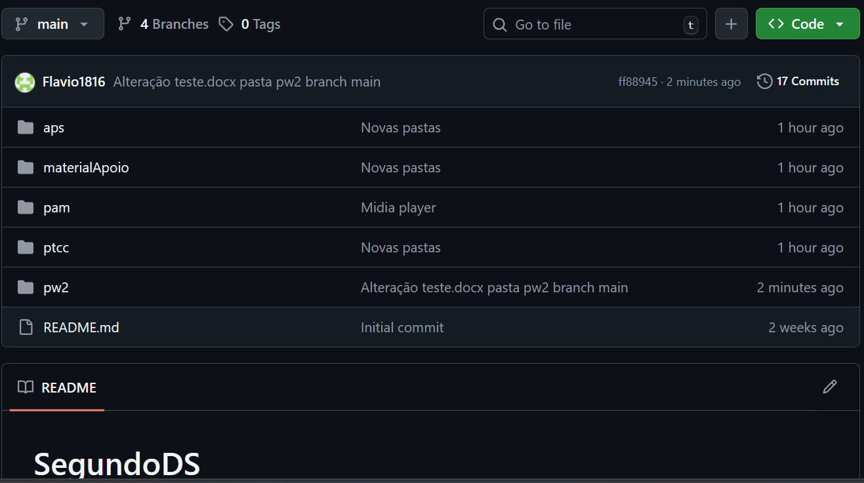

Trocar de pastas

flavi@Flavio MINGW64 ~/Desktop/DS02/SegundoDS/pw2 (main)
$ ls <- este comando, mostra o que tem na pasta pw2.
teste.docx '~$teste.docx' <- a pasta contém dois documentos

flavi@Flavio MINGW64 ~/Desktop/DS02/SegundoDS/pw2 (main)
$ ls –la -> <- este comando, além de mostrar os arquivos, mostra também arquivos ocultos.

total 25
drwxr-xr-x 1 flavi 197609 0 Feb 23 17:47 ./
drwxr-xr-x 1 flavi 197609 0 Feb 26 07:58 ../
-rw-r--r-- 1 flavi 197609 12766 Feb 23 17:45 teste.docx
-rw-r--r-- 1 flavi 197609 162 Feb 13 23:43 '~$teste.docx'

flavi@Flavio MINGW64 ~/Desktop/DS02/SegundoDS/pw2 (main)
$ cd .. <- este comando, volta uma pasta

flavi@Flavio MINGW64 ~/Desktop/DS02/SegundoDS (main)
$ ls
README.md aps/ bd2/ ds/ materialApoio/ pam/ ptcc/ pw2/ se/

flavi@Flavio MINGW64 ~/Desktop/DS02/SegundoDS (main)
$ cd aps <- este comando, entra na pasta com nome que foi selecionado “pasta aps”

flavi@Flavio MINGW64 ~/Desktop/DS02/SegundoDS/aps (main)
$

CRIAR BRANCH
Esta é um modo de criar uma branch
flavi@Flavio MINGW64 ~/Desktop/DS02/SegundoDS/pam (main)
$ git branch aldo <-este comando, criou uma branch com nome “aldo”

flavi@Flavio MINGW64 ~/Desktop/DS02/SegundoDS/pam (main)
$ git branch
aldo ------ nova branch aldo
daniel
flavio
* main <- mostra que você esta na branch main

flavi@Flavio MINGW64 ~/Desktop/DS02/SegundoDS/pam (main)
$
Outro modo
flavi@Flavio MINGW64 ~/Desktop/DS02/SegundoDS/pam (main)
$ git checkout -b mariana <-este comando, cria e já entra na branch com nome “mariana”
Switched to a new branch 'mariana'

flavi@Flavio MINGW64 ~/Desktop/DS02/SegundoDS/pam (mariana)
$ git branch
aldo
daniel
flavio
main
* mariana

flavi@Flavio MINGW64 ~/Desktop/DS02/SegundoDS/pam (mariana)
$

flavi@Flavio MINGW64 ~/Desktop/DS02/SegundoDS/aps (main)
$ git branch <- este comando, mostra quantas branch foram criadas

aldo
daniel
flavio
* main
mariana

flavi@Flavio MINGW64 ~/Desktop/DS02/SegundoDS/pam (flavio)
$ git checkout main <- este comando, mostra que troquei a branch flavio, por main

Switched to branch 'main'
Your branch is up to date with 'origin/main'.

flavi@Flavio MINGW64 ~/Desktop/DS02/SegundoDS/pam (main)
$

